CHRISTIAN’S MAGNIFICENT LaTex Style Guide

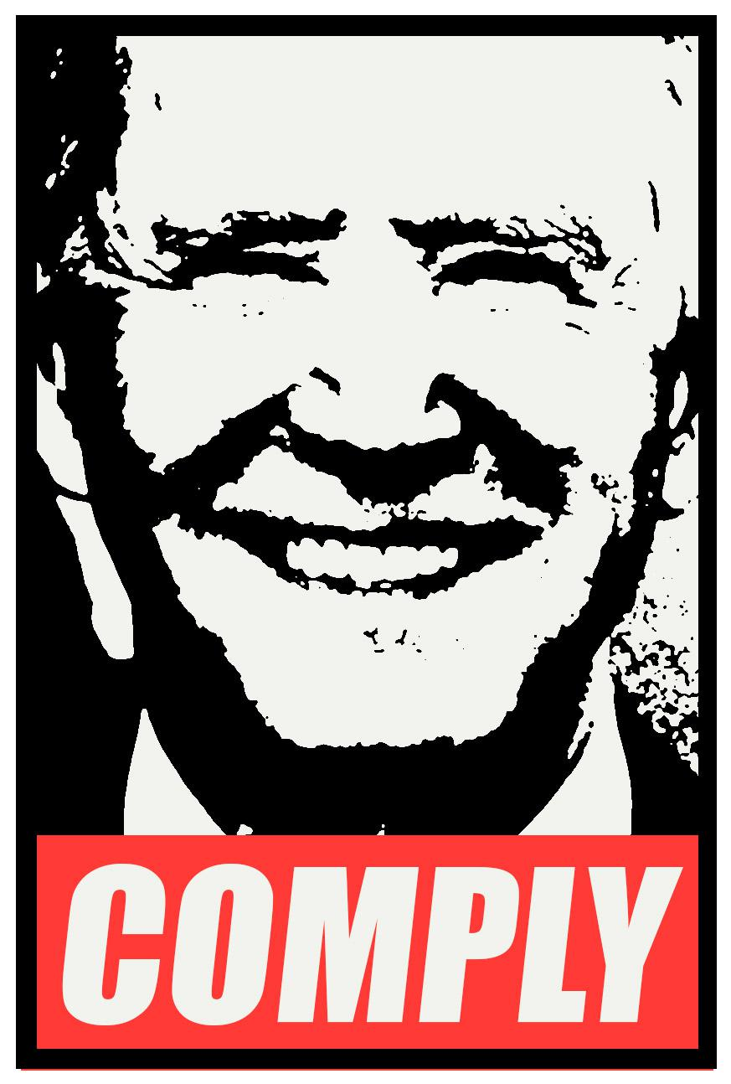

Contents

Figures 3

Single, free-standing figures: 3

Equations: 4

Single, free-standing equations: 4

Multiple equations, multiple equation numbers: 4

Multiple equations, single equation number: 5

Matrix example: 5

# General Rules:

## Labels:

* ONLY preface with object type, e.g. \label{eq:foo_equation} for an equation, \label{fig:foo_fig} for a figure.
* Labels must be so unique that chapter/section/etc references are unnecessary. Labels should indicate the nature of the object at first glance.
* Numbering is **100% forbidden**. If I see e.g. ”\label{fig:figure4} I *will* find you.
* References to objects always via the \cref command. This will automatically create text of e.g. the type ”Figure 6”.

# Figures

## Single, centered figures:

LaTeX:

\begin{figure}[h]

\centering

\includegraphics[width=0.8\linewidth]{Graphics/sim_lifting}

\caption[MPC Lifting Principle]{MPC Lifting Principle}

\label{fig:MPC_lifting}

\end{figure}

Result:

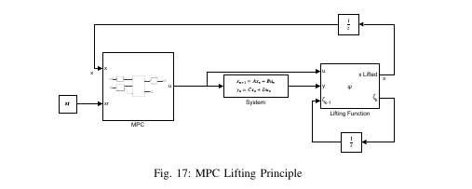

## Multiple figures, same line:

LaTeX:

\begin{figure}[ht]

\centering

\includegraphics[width=0.7\linewidth]{Graphics/MPC_Simple_Fig4}

\caption[Simple MPC]{Simple MPC controlling linear system}

\label{fig:mpc_simple}

\end{figure}

Result:

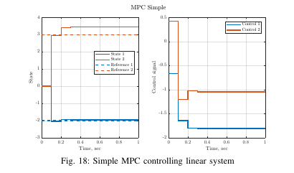

## Multiple figures, individual subcaptions:

LaTeX:

\begin{figure}[thpb]

\centering

\begin{subfigure}[t]{0.5\textwidth}

\centering

\includegraphics[height=2in,width=1\linewidth]{"Graphics/IFAC_controlled_v02"}

\caption{Control on $T_{sec}$ and $T_{SH}$, HDMDc-MPC}

\end{subfigure}%

~

\begin{subfigure}[t]{0.5\textwidth}

\centering

\includegraphics[height=2in,width=1\linewidth]{"Graphics/Dehghan_Control"}

\caption{Control on $T_{sec}$ and $T_{SH}$, \cite{Dehghan2018}}

\end{subfigure}

\caption{MPC tracking comparison, relaxed integral action}

\label{fig:MPC_IFAC_States_2}

\end{figure}

Result:

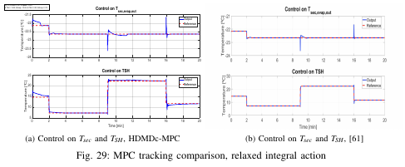

# Equations:

## Single, free-standing equations:

LaTeX code:

\begin{equation}\label{eq:MPCSys}

x_+ = Ax + Bu

\end{equation}

Result:



## Multiple equations, multiple equation numbers:

**Note that EACH equation has its own label**

LaTeX:

\begin{align}\label{eq:MPC:init}

&x(0) = \bar{x} \\

&x(k+1) = A \, x(k) + B \, u(k)

\label{eq:MPC_sys_dym} \\

&x_{min} \leq x(k) \leq x_{max} \label{eq:MPC_x_constraint} \\

&u_{min} \leq u(k) \leq u_{max} \label{eq:MPC_u_constraint}

\end{align}

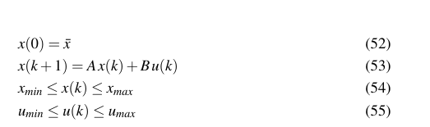

## Multiple equations, single equation number:

**Note that the entire set of equations has ONE label**

LaTeX:

\begin{equation}\label{eq:MPCQP}

\begin{alignedat}{2}

&\text{minimise} \quad &&\frac{1}{2}\sum_{k=1}^{N_{p}}(x[k]^TQx[k] + u[k]^TRu[k]) + \frac{1}{2} x[N_{p}+1]^TQ_{N_{p}+1} \, x[N_{p}+1] \\

&\text{subject to} \quad &&x[k+1] = Ax[k] + Bu[k] \\

& &&E_kx[k] + F_ku[k] \leq b_k \\

& &&E_{N_{p}+1} x[N_{p}+1] \leq b_{N_{p}+1}

\end{alignedat}

\end{equation}

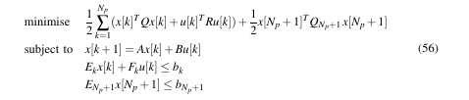

## Matrix example:

LaTeX:

\begin{equation}\label{eq:DenseFormConstraints}

\begin{alignedat}{2}

Q_D &\triangleq

\begin{bmatrix}

I \otimes Q & \bar{0}\\ \bar{0} & Q_{N_{p}}

\end{bmatrix}, \quad R_D &&\triangleq I \otimes R \\

E_D &\triangleq \begin{bmatrix}

I \otimes E & \bar{0} \\ \bar{0} & E_{N_{p}}

\end{bmatrix}, \quad F_D &&\triangleq I \otimes F

\end{alignedat}

\end{equation}

Result:

